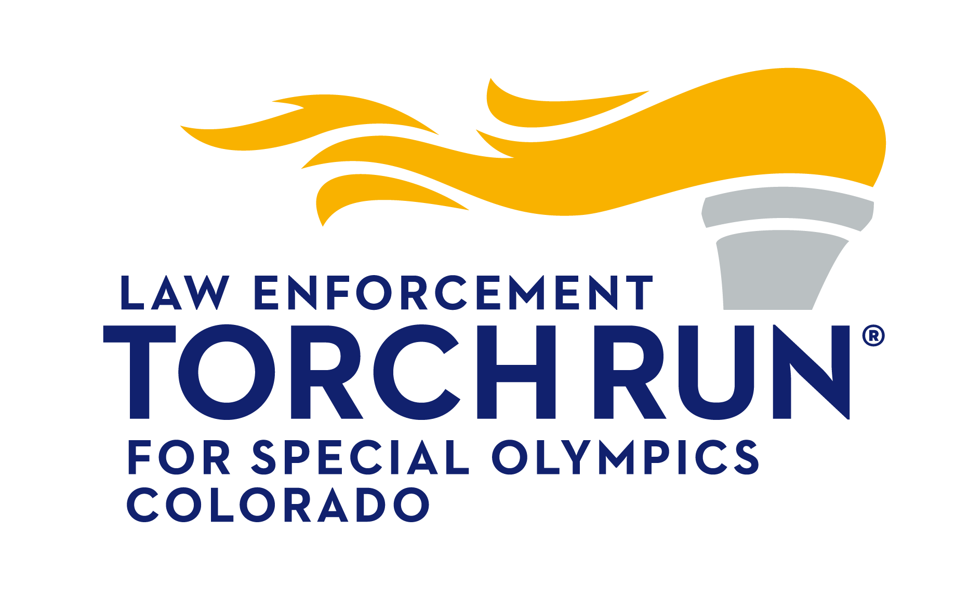
2022 STARLITE CLASSIC CAR & MOTORCYCLE SHOW

Sunday, August 21st, 2022
(Set-up 8AM-10AM, Judging starts at 11am, Awards at 3PM)
Boulder Creek Hometown Festival | Boulder, CO
13th Street (between Arapahoe and Canyon)
*PROCEEDS BENEFIT SPECIAL OLYMPICS COLORADO*
Awards: In the “spirit” of our courageous Special Olympics Athletes, each of the following (10) judged classes will receive awards for the top three places (1st-Gold, 2nd-Silver and 3rd-Bronze medal winners).
Original/Restored Stock: Class A (1900-1959), Class B (1960-1984)
(All cars/trucks, except Corvettes and American Muscle class vehicles)
Modified: Class C (1900-1959), Class D (1960-1984)
(All cars/trucks, except Corvettes and American Muscle class vehicles)
American Muscle (1964-1972): Class E (Original/Restored Stock), Class F (Modified)
(V-8 muscle cars; camero, el camino, chevelle, firebird, GTO, 442, GS, mustang, cuda, challenger, AMX, Javelin, etc)
Corvette (1953-1984): Class G (Original/Restored or Modified)
Street Rod: Class H (1900-1949)
**NEW CLASS**: Class I (All 1985-Present) *Eligible for All Specialty Awards except Best of Show.
Motorcycles: Class J (All years American and Foreign made)

Specialty Awards:
*Boulder Strong*Best of Show (The winner will be selected from the judged list of ALL 1st Place “Gold Medal” winners from each class)
*Honorary Officer Eric Talley*Top Cop Award (The winner will be selected from the judged list of ALL registered participants/owners who are current or retired law enforcement)
*Honorary Teri Leiker*Flame of Hope Award (A committee of Special Olympics Athletes will select the winner from the list of ALL registered participants)
StarLite Award (A committee from the Boulder Creek Events staff will select the winner from the list of ALL registered participants)
Club Award (Presented to the car or motorcycle club with the most "registered" members)
People's Choice Award (Presented to the car or motorcycle with the most votes from anyone attending the Car Show and Hometown Festival. One vote per person.)

Definitions:
Original/Restored Stock Classes: Body/paint, rims/wheels, interior, and engine must appear to be visibly stock for vehicle year and model. Correct reproduction parts, internal engine modification, header exhaust system, and different tire size are acceptable.
Modified Classes: Simply put; any non-factory appearance involving body/paint, interior or engine; including, any visible aftermarket engine parts/chrome, rims/wheels, or custom interior or paint/body fabrication.
REGISTRATION FORM
Name: ____________________________________________________
Mail registration forms to:
Boulder Creek Events
PO Box 108
Boulder, CO 80306
303-449-3137

Address: __________________________________________________
City: ________________State: __________Zip: _________________
Phone: ___________________ Cell: ____________________________
Email: ____________________________________________________
Year: ___________ Make: ______________ Model: ______________ Color: __________
- Door Prize Ticket
- Dash Plaque for the first 100
Classification: ______________________________________
Law Enforcement Agency affiliation ____________________ circle: Active or Retired
Club Affiliation: ___________________________________________________
How did you hear about the show? ____________________________________
Car Show event T-shirts are $10 for pre-registration; $15 day of event
How many shirts? Size: ____ S ____ M ____ L ____ XL ____ XXL (+$2.00)
Pre-registration fee: $25 (Donation to Special Olympics Colorado; Must be postmarked by August 10th)
Day of event registration fee: $35
TOTAL $_________
Checks and Credit Cards are accepted (Cash accepted on day-of-event). Make checks payable to: Boulder Creek Events
Credit Card #_________________________________ Exp. ______________CVC __________ Card Type ______________
By entry you hereby agree to the following: in consideration of the acceptance of the right to participate, entrant, participants, and
spectators, by execution of this entry form, release and discharge the City of Boulder, the event planners – Boulder Creek Events, Special Olympics Colorado, Law Enforcement Torch Run Colorado, event volunteers, and event sponsors, if any, from any and all known and unknown damages, injuries, judgments, and/or claims from any cause whatsoever that may be suffered by and entrant to his/her persons or property. Participants are liable for all guests. All participants agree to have valid vehicle insurance and will provide proof if asked. Additionally, participants agree to allow the use of names and photos associated with their entry for publicity and advertising purposes. Owner/Participant Signature X
____________________________________

